

**SOCIAL/ SALES/ INDUSTRY INTERNSHIP**

BACHELOR OF SCIENCE

In

Data Science and Analytics

By

Renuga Devi. A

C3S48860

Under the Supervision of

Dr.G.Preetha

[Duration: 18th June to 26th June 2024]

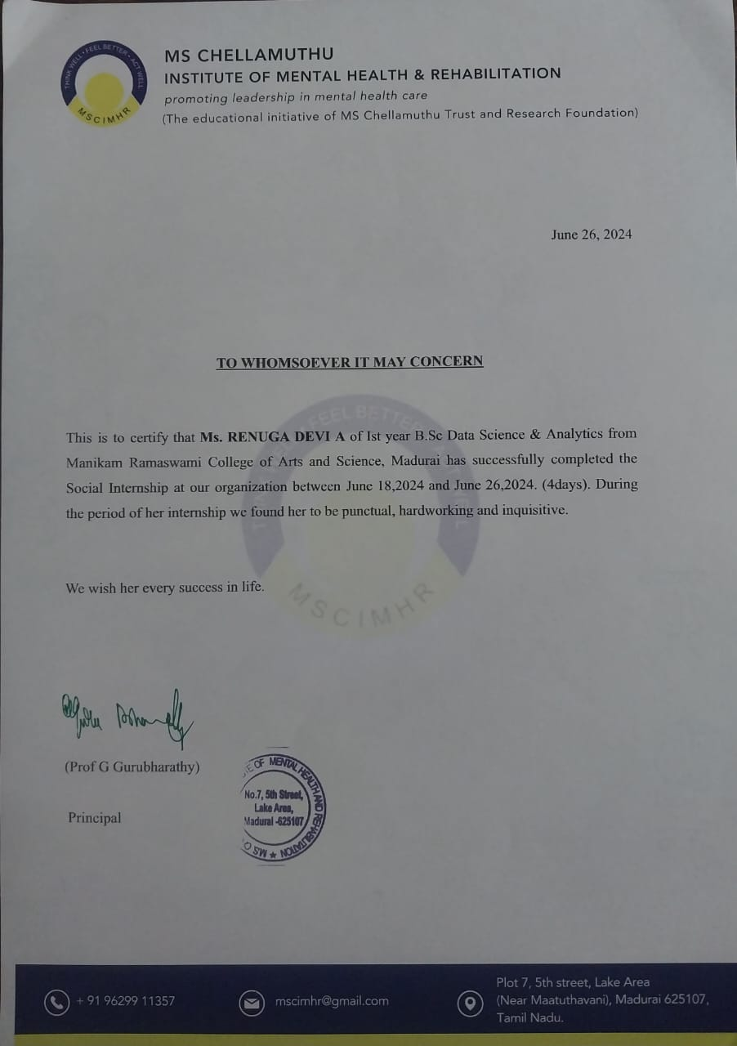

**ACKNOWLEDGEMENT**

I wish to express my deepest gratitude to our correspondent Mrs.M.Valli Ramasamy who have made this internship experience possible.

I would express my heartly thanks to my supervisor’s and professor’s Mrs. Subiksha and Mrs. Preetha who guidance and support where markable throughout this journey and I would like to thank the principal for granting me this opportunity and for supporting my professional development.

I am immensely grateful to Miss.Veena Vidyasri the organization supervisor for providing me with this opportunity to work as intern at M.S. Chellamuthu trust. Her leadership and dedication to the organization is truly inspiring.

Finally, my sincere thanks to all the supervisor of the various initiatives within the trust, whose ability and patience contributed to my learning their willingness to share their knowledge and experiences has been an important feature to my internship.

Thank you all for your support and guidance.

**ABSTRACT**

The social internship at M.S.Chellamuthu trust gained valuable experience in mental health awareness and care. The trust runs various initiatives, including Ahana hospital, Bodhi campus, Aakash special school,ECRC,and Trishul De-addiction centre. I gained exposure to data collection, record management, sensor integration treatment, emergency care and de-addiction services. The internship also provided valuable insides into the trusts importance and helped to develop social skills. I am satisfied with their volunteer time and the opportunity to understand their potential.

## 

## **CONTENTS**

## **1) Organization profile.**

## **2) Introduction.**

## **3) Timeline and history of trust.**

## **4) Functional and aspects of the organization.**

## **5) Day wise activities:**

**5.1 Day1**

**5.2 Day2**

**5.3 Day3**

**5.4 Day4**

**5.5 Day5**

**5.6 Day6**

**5.7 Day7**

**6) Conclusion.**

**7) Appendix.**

**8) References.**

**1.ORGANIZATION PROFILE:**

M.S.Chellamuthu Trust and Research Foundation was founded in the year 1992 by Dr.C.Ramasubramanian(M.D., D.P.M., Ph.D.), Consultant Psychiatrist based at Madurai, Tamil Nadu to address the rehabilitation needs of the persons with mental disabilities. The Institution based rehabilitation initiatives of the Trust has transformed the life of the persons with mental disabilities and their families. The community initiative of the Trust started with the support of Anheri Hilfe,Germany to ensure that the poor in the villages have access to mental health services has become a benchmark in Community Psychiatry. The Trust is also instrumental in shaping the District Mental Health Program launched in Ramanathapuram District of Tamil Nadu after the Erwadi Fire tragedy. As a recipient of National Award from the Ministry of Social Justice and Empowerment, Government of India, New Delhi, the Trust has appeared as a harbinger of hope to the millions of people suffering from mental illness and living in a state of hopelessness. Their vision and mission are, Mental Health for All. To promote mental health through holistic care that is affordable and accessible to all.

**2.INTRODUCTION:**

M.S. Chellamuthu Trust and Research Foundation is a Non-Governmental, Non-Profit, Secular, organization registered as a Trust under Indian Trust Act. M.S. Chellamuthu Trust and Research Foundation provides comprehensive mental health care for children, adults, and elderly with mental disabilities for almost three decades. They run six homes for 300 homeless persons with mental illness and mental retardation, providing food, stay, medication, treatment, and vocational training. The Trust also supports over 15,000 people with mental disabilities and their family members in rural areas through a community-based rehabilitation program. They also run an Alcohol and Drug De-addiction centre and an institute for mental health education. The objective is to help people understand the importance of mental health and that mental illness is preventable, treatable and curable if identified at the earliest.

**3.TIMELINE AND HISTORY OF TRUST:**

1992 - Chellamuthu trust founded

1994 - Chellamuthu gardens established

1995 – Official recognition as a research centre and Aakash school was created

1997–State’s best non-governmental organization award by the government of Tamil Nadu

1998 – Vocational training and placement unit started

2000 – Community mental health project started

2007 – Nation’s best NGO award

2008 – Establishment of M.S. Chellamuthu institute and Ahana hospital

2013 – Telepsychiatry unit started

2018 – Care Factory started &amp; Happy schooling programme kick off

2020 – Speak 2 Us mental health helpline inaugurated

2021 – Police wellbeing programme launched

**4. FUNCTIONAL ASPECTS OF THE ORGANIZATION:**

* Mental health for Homeless persons.
* Community based projects.
* Vocational training and rehabilitation.
* Child mental health.
* Residential re-habitation.
* Deaddiction and Aftercare.
* Support services programs for families and caregivers.
* Education and training.

**5.DAY WISE ACTIVITIES:**

5.1 DAY 1:

On the first day of our social internship, we learned about the M.S.Chellamuthu Trust`s commitment to mental health awareness and its initiatives. Then visited one its initiatives Ahana hospital at the afternoon, there we had a conversation with Mrs Bijulakshmi about data collection and analysis in mental health care. We toured the hospital`s department, saw the practical applications of mental health care techniques and treatments, and learned about its outreach programmes. We engaged in discussions about the challenges faced in the mental health sector and the innovative solutions being developed.

5.2 DAY 2:

The next day the bodhi campus of Chellamuthu trust, Pitchai vel sir an official provided an overview of the campus’s history and services. Visited various sections, including the record and documentation section, where we learn about the digitalization of physical records, the use of personalized and familiar software for record handling and research activities. Also reviewed the case histories and records gaining fundamental knowledge about data collection and scales used in the rehab process, which helps them handle records perfectly.

5.3 DAY 3:

The day 3 of internship is assigned to Aaakaash special school inside the bodhi campus, we learned about the school`s unique features and daily routines, gaining insight into its significant training for students. And they are providing free special education, food, medication, uniforms, books, transport, occupational and speech therapy, cultural and sports events. The school`s history is impressive. We helped the children in various activities and observed them closely, which helped our observation. Interaction with the students was also beneficial after a brief observation period.

5.4 DAY 4:

The day 4 is with Aaakaash special school of Chellamuthu trust as yesterday. It is a School for 60 rural children with mental retardation. The focus was on sensory integration treatment, which helps children learn through the inner instincts. The internship allowed us to see the student's achievements and records, as well as their appreciative environment, which is the change making environments for these children.

5.5 DAY 5:

On the fifth day of our internship, we visited the Emergency Care and Recovery Centre (ECRC) in the Chellamuthu trust. National Health Mission, Institute of Mental health, Chennai, Banyan are their partners of collaboration. The centre plays a crucial role in mental health care and provides meaningful interactions with residents who share their recovery journeys. We actively took part in volunteer activities, such as therapy sessions and recreational activities, to gain firsthand insights into the daily challenges faced by individuals with mental health issues and reduce stigma, highlighting their integrated approach to support individuals through treatment and reintegration into society. The process of outreaching, rescue, rehabilitation, reintegration is followed there. We toured the residential centre and therapeutic facilities and the resources available to support resident’s recovery journeys.

5.6 DAY 6:

We visited the Trishul de-addition centre, a project supported by the central government and managed by M.S. Chellamuthu trust. It is place for helping individuals, families and communities struggling with substance use and addiction disorders. Partnership with Ministry of Social Justice and Empowerment, New Delhi. Dedicated 30-bed facility. We were oriented about the centre's history and services and had the opportunity to interact with the residence and practice in educational awareness session about the drugs. we also had a conversation with the centre head, which enriched our understanding of the field and got the information about detoxification process is done there for patients (first 2 to 3days) from the day of their admission. And involved in their recreation activities.

5.7 DAY 7:

The final day is assigned at care factory of Chellamuthu trust, it is the pre-placement place for mentally unstable and physically challenged people. Family Fellowship of the persons with mental disabilities. The objective is to enable the members of the family to support each other and help them become stronger. There the resident was helped for going with the large the corporate industries like TVS etc., the process of training and implementing phase is seen there. The residents are given salary based on their work and working hours. Then we saw the products and interacted with their trainees in baking, printing, tailoring and soap making. At the afternoon we went to the Chellamuthu trust there the internship coordinator Miss Veena Vidyasri oriented about Happy schooling project and the coordinator of speak2us oriented about their project. At last, we received our internship completion certificate from our internship coordinator.

**6.CONCLUSION:**

My internship at MS Chellamuthu Trust offered invaluable insights into the field of mental health rehabilitation. Over the course of seven days, I saw firsthand the compassionate care and effective rehabilitation strategies implemented by the Trust. This experience not only enhanced my understanding of mental health disorders but also underscored the importance of holistic care and community support in the recovery process. I got to know about value of empathy. And learnt about effective data management in improving patient outcomes and have gained practical knowledge and skills that invaluable in my future actions. The supportive environment and expert guidance from the staff influenced in my professional and personal growth.

**7.APPENDIX:**

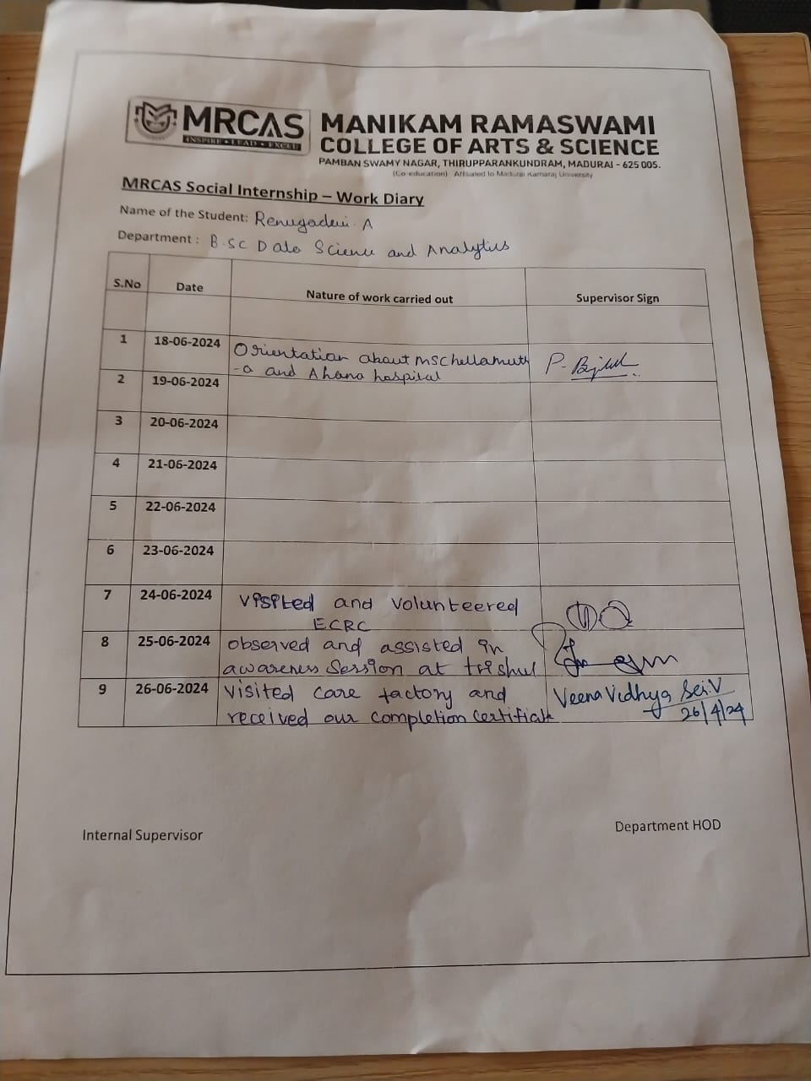

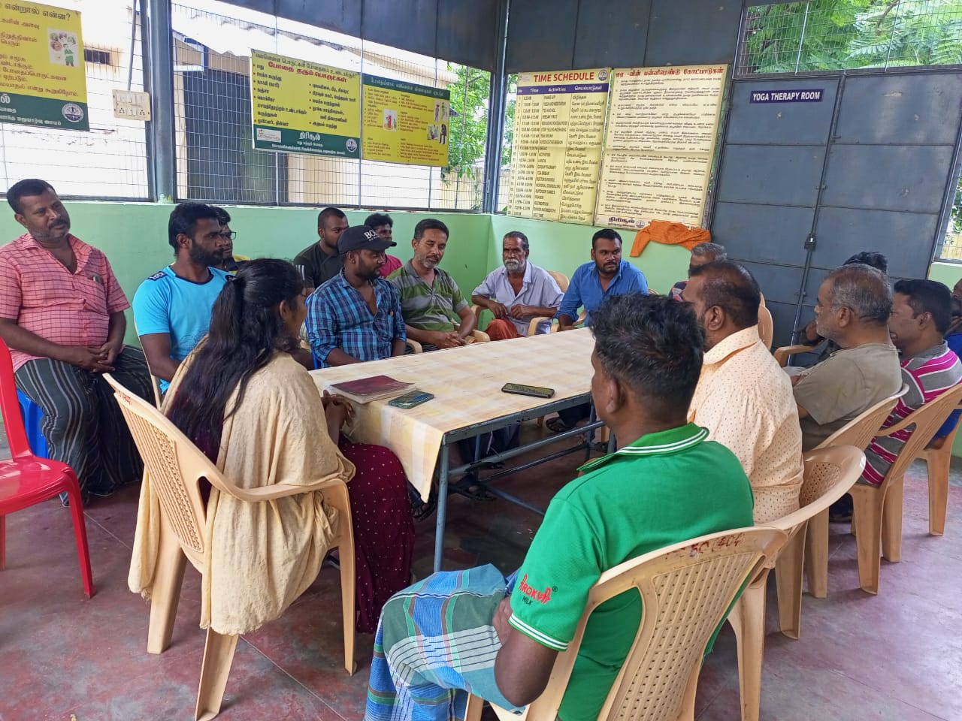

Trishul de-addiction centre

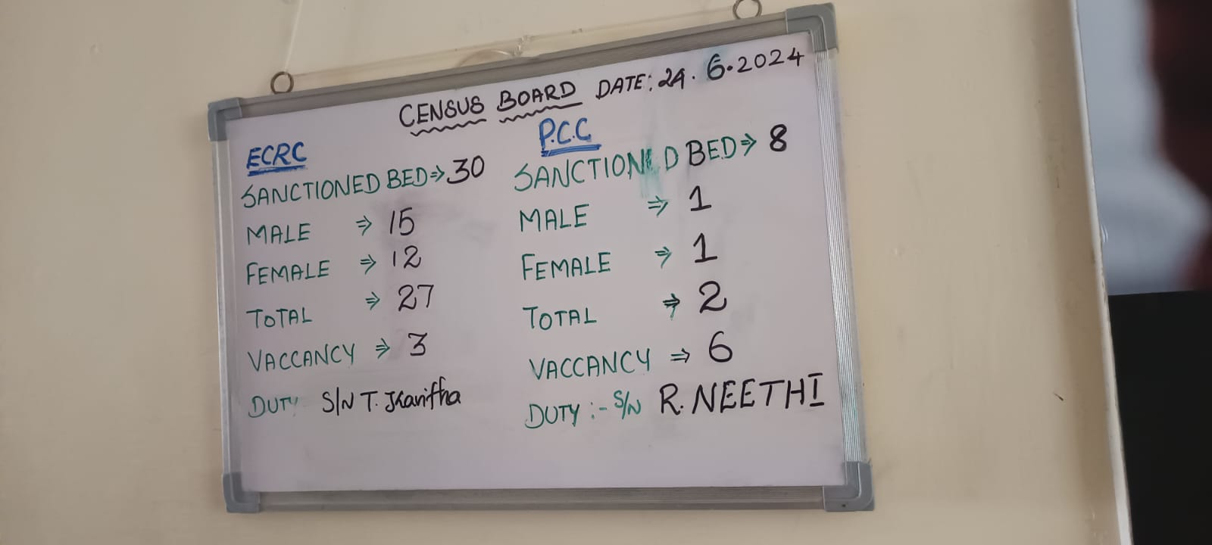

Emergency care and Recovery centre

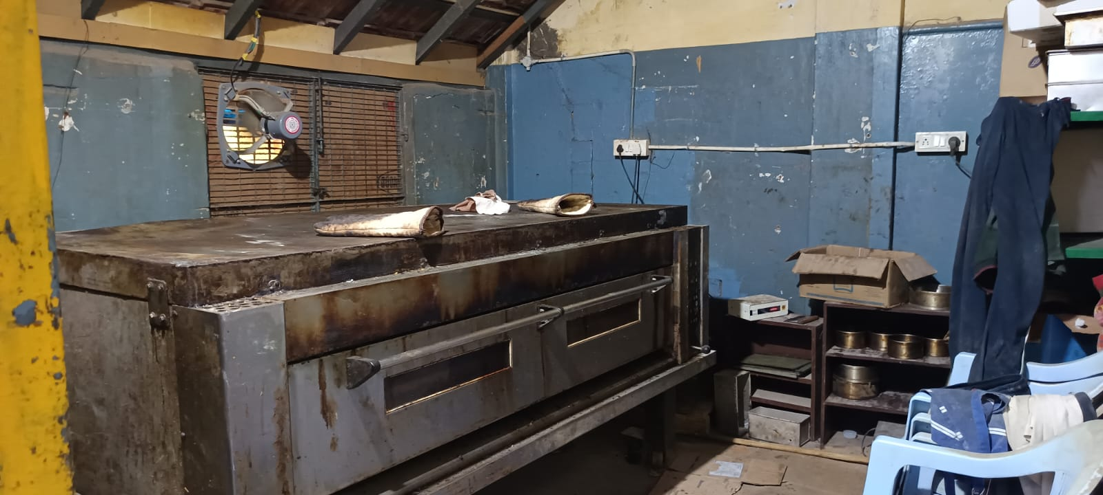

Care factory-printing section

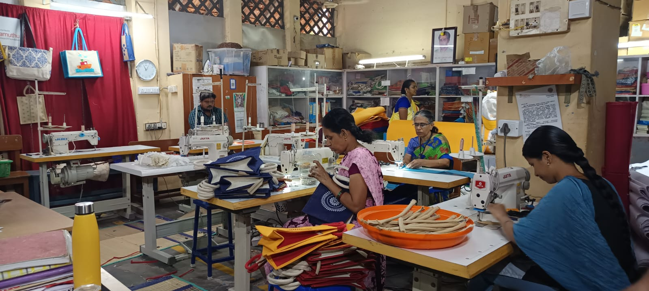

Care factory- Craft section

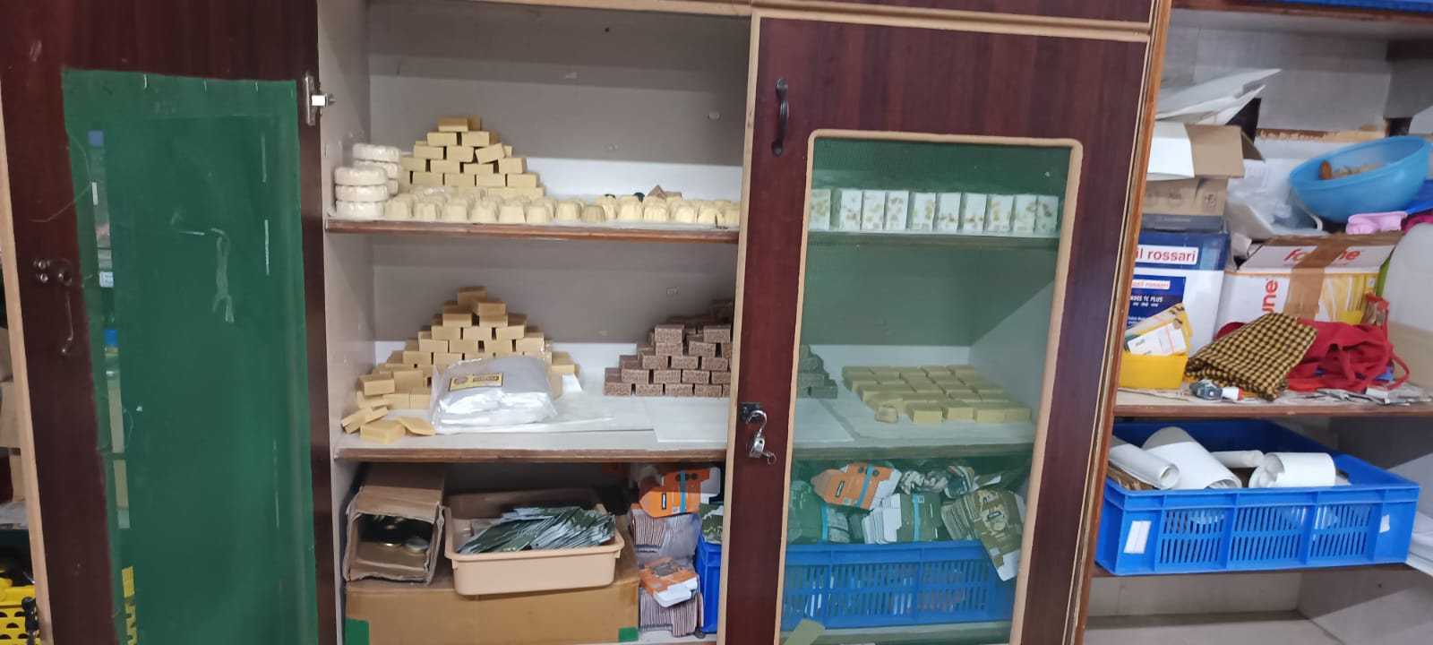

Care factory- Soap making section

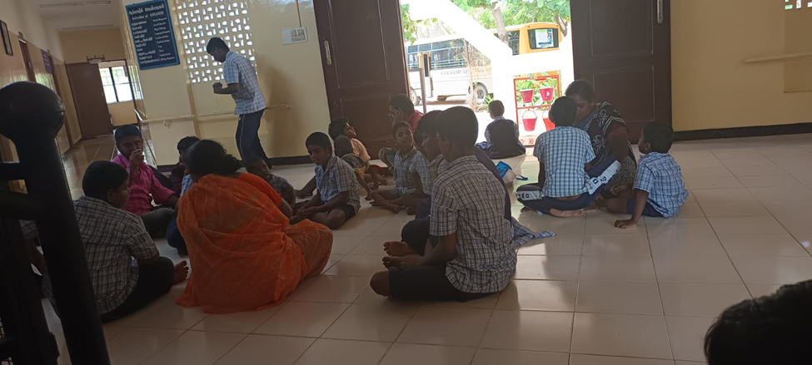

BHODI campus

PARTNERS & SUPPORTERS:

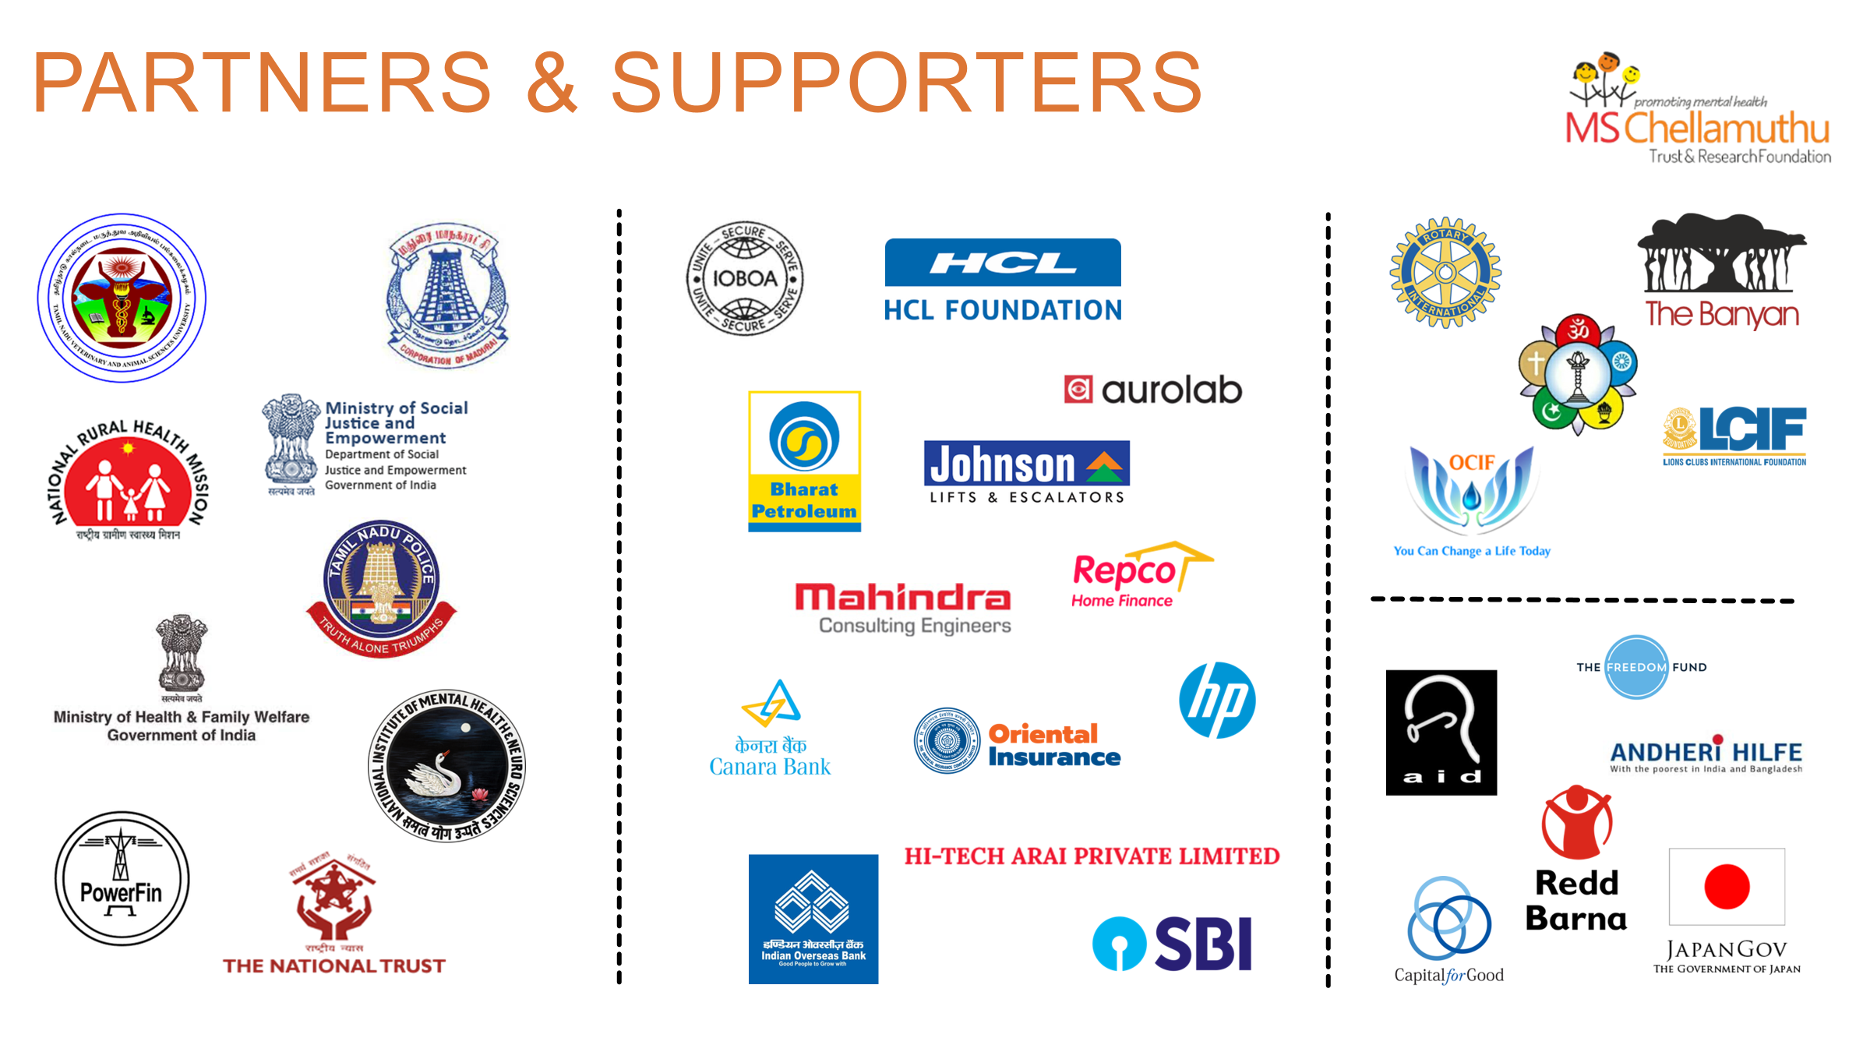

**8.REFERENCES:**

**https://msctrust.org/**